**Ansible enterprise Setup**

* Lets create 3 VMs
  + ubuntu 18 VMs => 2
  + centos 7 VM => 1
* Once the 3 VMs are running
  + Lets create one user called as *devops* on all the three server and give this user sudo permissions without prompting for password
* Creating user with password in Linux
  + Check if password logins are allowed
    - Change PasswordAuthentication to yes in /etc/ssh/sshd_config and restart sshd service using sudo service sshd restart
  + Now create a user called as devops
* sudo adduser devops
  + Lets add sudo permissions to the devops user without password
* sudo visudo

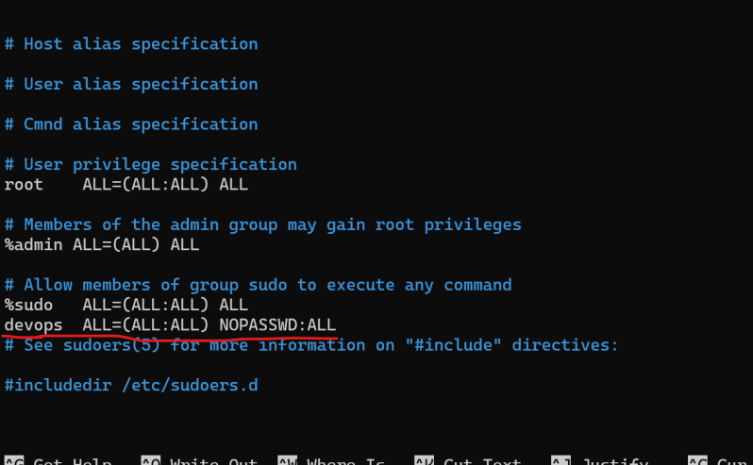

* + Repeat the same activity on the other ubuntu server
  + Repeat the same activity on the centos7

sudo useradd devops

sudo passwd devops

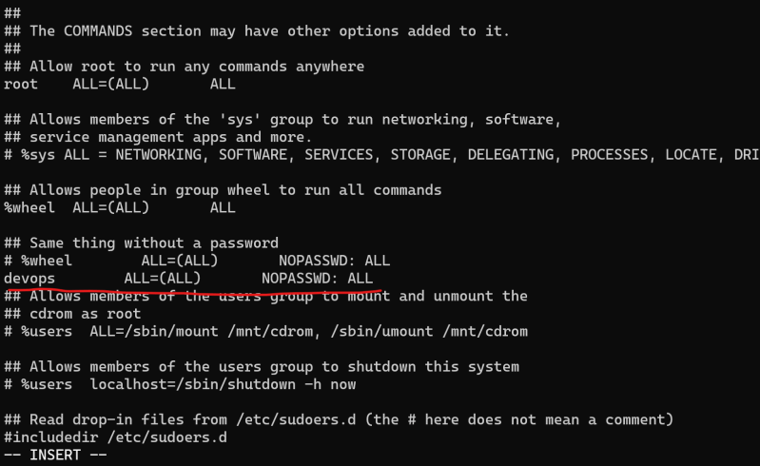

* Install ansible on the control node (ubuntu)
* Ansible has configurations present in /etc/ansible
* Now lets create a configuration in such a way that devops user will be able to login into the nodes without prompting for passwords
  + Lets create a key pair in ansible control node
* ssh-keygen

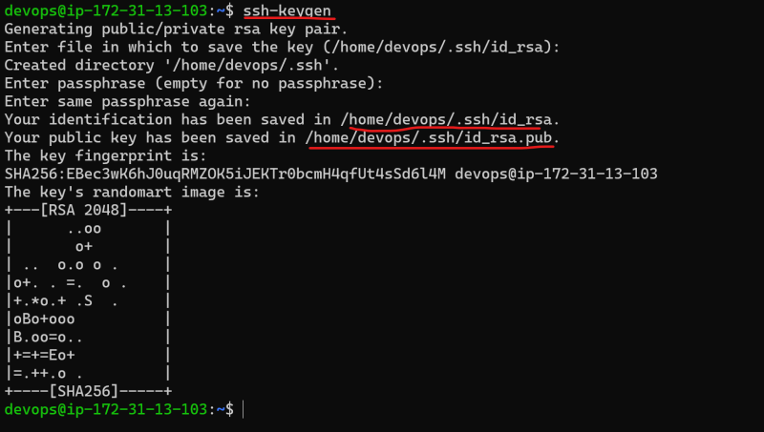

* + Now lets copy the public key to the nodes and let ssh verify the connection using keys

ssh-copy-id -i ~/.ssh/id_rsa.pub <user-id>@<x-host> //Command to copy password